1. Windows Installation can be done by use of a bootable flash drive or DVD drive. I used a bootable flash drive using Rufus application which can be downloaded for free from the Rufus website and wrote the ISO file to the flash drive, in this case, I used windows 10. After the steps for making the flash bootable are done and writing the ISO file. The Installation of Windows can start.
2. I inserted the bootable flash drive to the computer and restarting the computer. When it is restarting, a setup screen will appear where I selected the boot menu using F9 and then selecting the boot device (SanDisk) from a list of boot sources that were given.

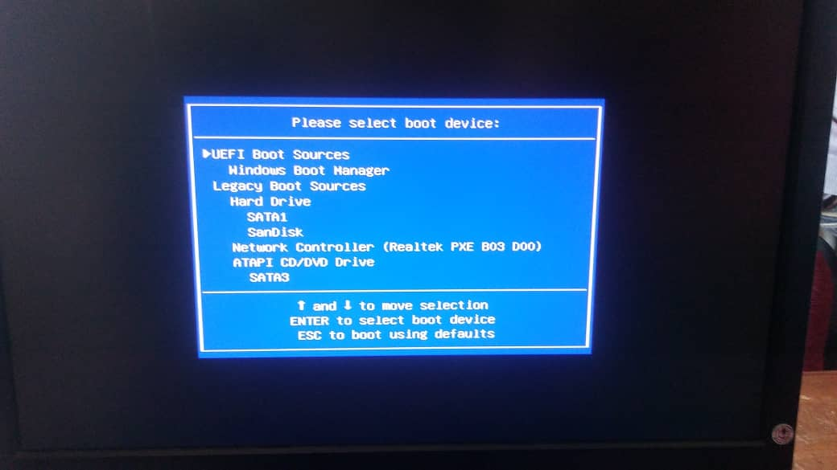

I chose Windows 10 pro STD as the OS to be installed, entered next and then agreed to the licensing agreement. Afterwards, I selected upgrade as the type of installation, which are to upgrade (it is only available if the computer is already running on a supported version of Windows and you wish to upgrade to Windows 10 and allows to keep all files).

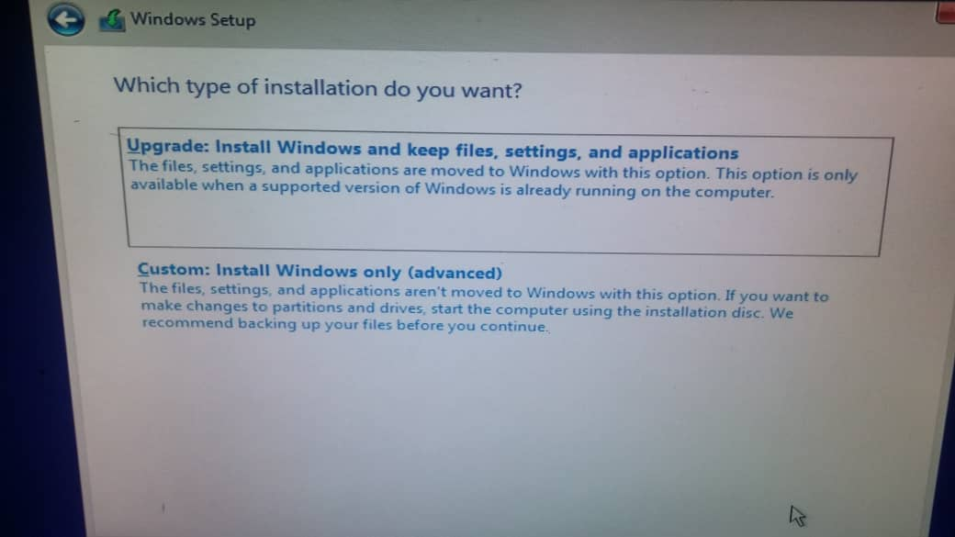

Next I selected where I want to install Windows between the partitioned drives, in this case I selected the first one which was rejected due to disk space so I selected the 4th drive. After all this, windows started installing.

1. Required drivers and source location
2. Unresolved issues
3. I used AVG antivirus which can be downloaded for free from the AVG website
4. The key stages in this installation are as follows:

* The first thing I did was download AVG installation file and when it finished downloading, I ran the downloaded file which started the installation process.

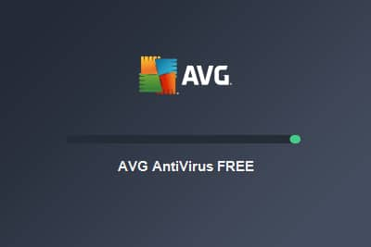

* I set my preferred language and selected to agree to license agreement.

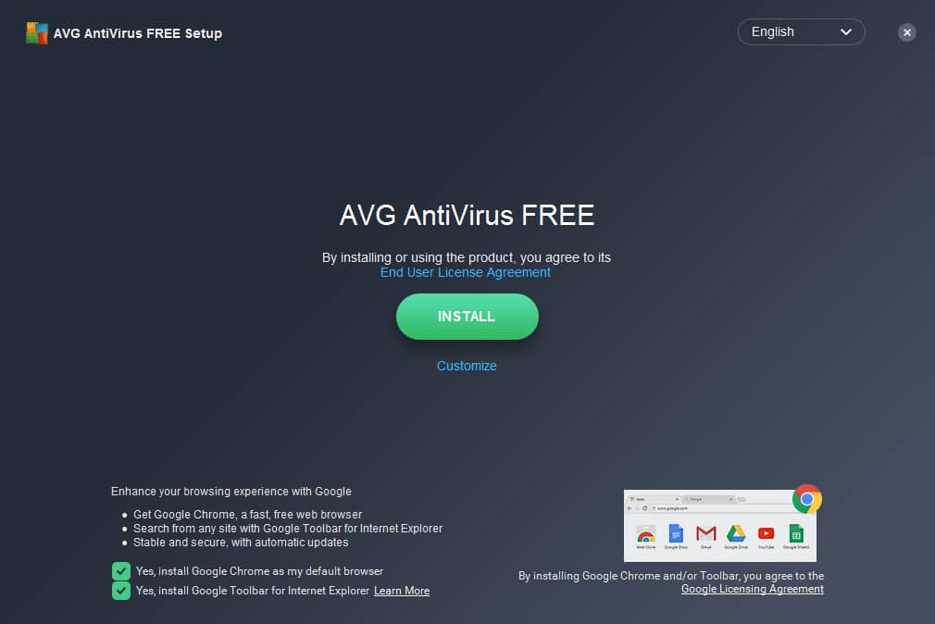

* After the installation was done, I restarted the computer as required by the application and after it restarted, I ran the antivirus software with the following result

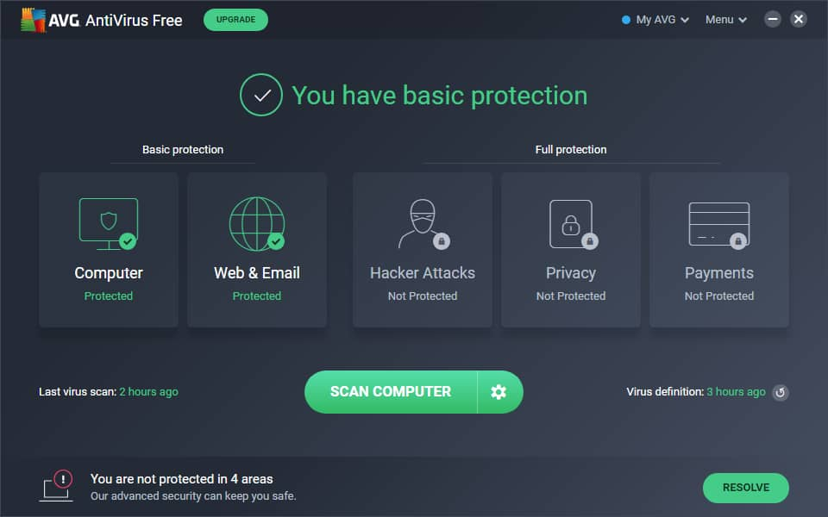

1. I had no problems or unresolved issues with the antivirus
2. The software can be upgraded automatically or manually using the file available on the AVG website and following the steps that follow

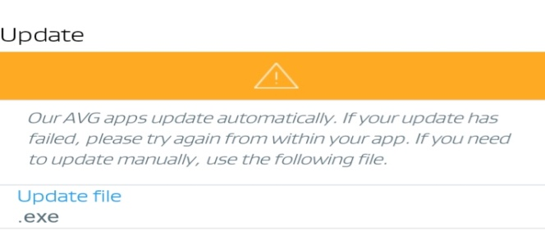

1. Installation of office
2. I used Microsoft Office professional plus 2010 for this installation and I had the installation files on a flash drive.
3. The steps I took are as follows

* I opened the flash contents and selected the setup file and the installation process started first by asking to agree to the Software license

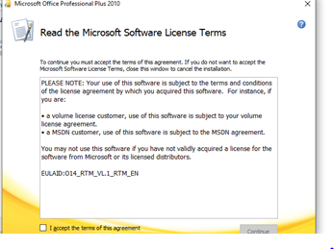

* The next thing I did was selecting the installation I wanted between to install now or customize of which I chose to install now.

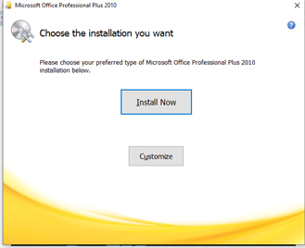

* After the completion of the installation was completed, the following screen was displayed

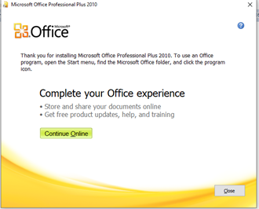

1. Free utility